**Azure Key Vault**

* **Secrets Management** - Azure Key Vault can be used to Securely store and tightly control access to tokens, passwords, certificates, API keys, and other secrets.
* **Key Management** - Azure Key Vault can also be used as a Key Management solution. Azure Key Vault makes it easy to create and control the encryption keys used to encrypt your data.
* **Certificate Management** - Azure Key Vault is also a service that lets you easily enroll, manage, and deploy public and private Transport Layer Security/Secure Sockets Layer (TLS/SSL) certificates for use with Azure and your internal connected resources.

**Azure Key Vault has two service tiers:**

Standard, which encrypts with a software key,

Premium tier, which includes hardware security module (HSM)-protected keys.

To see a comparison between the Standard and Premium tiers, see the [Azure Key Vault pricing page](https://azure.microsoft.com/pricing/details/key-vault/).

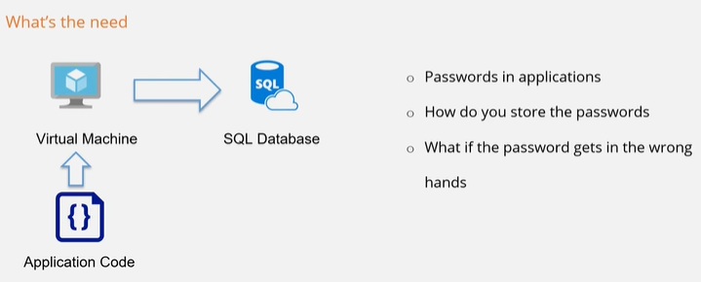

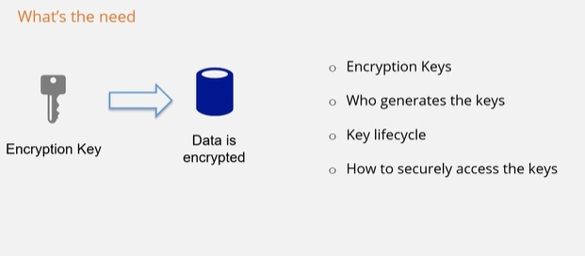

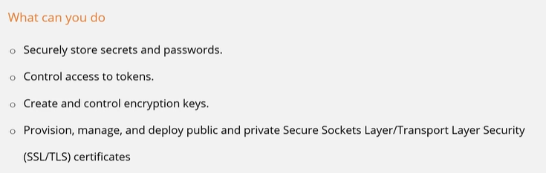

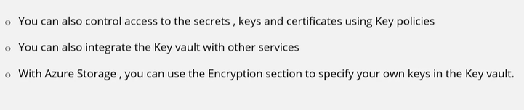

**Key Vault Lab:**

